6FTC2175 Advanced Machine Learning and Neural Network (ANLNN)
Assignment 1 Title: Comparing Classical Machine Learning and Neural Network Approaches for Predictive Quality Control
Student name: Parina Roshan Sharma
ID: 25370M55

1. Introduction
Automated defect detection helps manufacturers identify products that have fault in them this helps in reducing scrap , rework and warranty costs factor has two data sources to detect defects one of them is Tabular process data which contains information like weight of the product or time of arrival or size whereas Image data has photos of products these images to identify visible defects such as cracks or tears classical machine learningg suits structured tabular data, whereas convolutional networks learn visual features directly from pixels (LeCun et al., 1998; Goodfellow, Bengio and Courville, 2016)this report compares three models a Random Forest (Breiman, 2001) and a multilayer perceptron (MLP) on tabular process data and a convolutional neural network (CNN) on casting images. Its objectives are to interpret the experimental evidence critically identify each model’s trade-offs and recommend a defensible deployment strategy.

2. Methodology
Two Kaggle datasets were used the Manufacturing Defects dataset (El Kharoua, 2024) provides information such as DefectStatus target, whereas the Casting Product dataset (Dabhi, 2020) contains photos of a submersible-pump impeller labelled OK or defective tabular data were split 80/20 with stratification before analysis A leakage audit on training data removed DefectRate and QualityScore, which derive from the outcome (Kaufman et al., 2012); cross validated PR-AUC fell from 0.966 to 0.947, the more honest estimate mputation and scaling were fitted on training rows only. images were resized from 300×300 to 128×128 pixels; the supplied test folder (715 images) was retained and 994 of the 6,633 training-folder images formed a validation set.
Random forest was trained using different ways where dataset is divided in 5 parts where model is trained on 4 parts and and in the MLP used backpropagation d early stopping to classify and understand images and i compared a baseliine CNN with an improved CNN

3. Critical Analysis

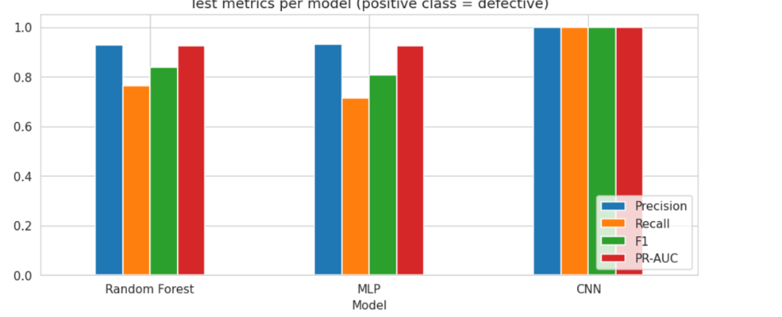

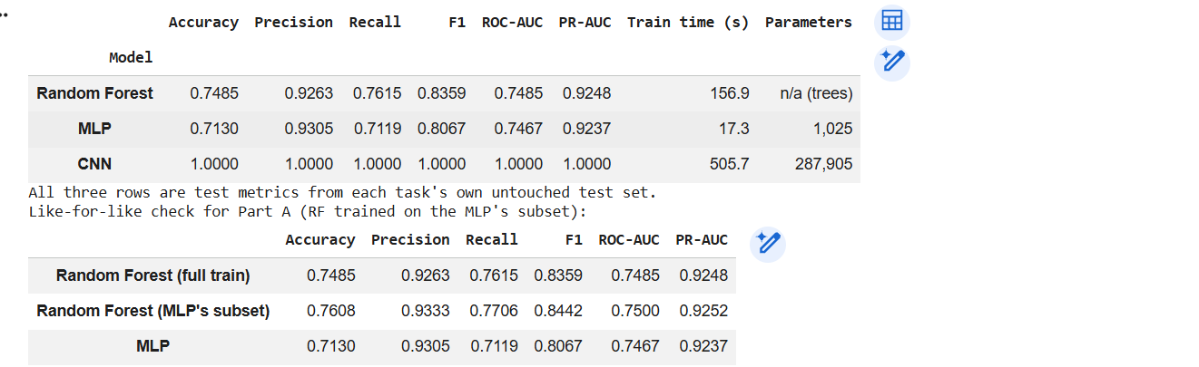

As we can see in the graph random Forest was better at detecting defective products than the MLP On tabular data both accuracies fall below the 84.1%although both models had limited predictive power .Random Forest missed 130 of 545 defective units (24%) at the 0.5 threshold and for MLP’s smaller training subset (recall 0.771, F1 0.844), so data volume does not explain it However ROC-AUC was essentially tied (0.747–0.750) CNN achieved better validation loss than the baseline and recorded 100% accuracy on 715 test images but also the CNN solves a different and potentially easier problem because defects are directly visible in images
his does not make the CNN a best model It tackles an easier problem where defects are visible imaging conditions are fixed and labels are clean whereas the tabular signal is weak, so the results are not the best a perfect score also demands carefully examined things The duplicate-image check found test images also present in the training folder, yet excluding exact and nearduplicates left every meturic at 1.000 so leakage does not explain the result (Barz and Denzler, 2020). Even so, zero errors in 715 images bounds but does not have a zero error rate and each model was trained only once.

Why three models perform different for random forest each learns different patterns from the training data The trees are designed to be less together with one another combining their predictions reduces variance and can improve generalisation.Breiman (2001) supports the Random Forest method. The study by Grinsztajn, Oyallon and Varoquaux (2022) supports the broader observation that tree-based models often perform strongly on the medium-sized tabular dataset the MLP uses an artificial neural network with layers for its first layer 32 neurons are used and for its second layer it was trained on only 2,203 rows. With a relatively small dataset the MLP may have difficulty to learn useful patterns that generalize well to products it didn’t learn on and which are completely new to it CNN is designed for images that is the main advantages and so are local connectivity and weight sharing local connectivity means convolutional filters examine small regions of an image at a time and weight sharing means the same filters are reused across different image location
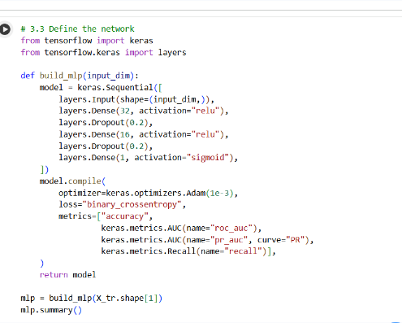
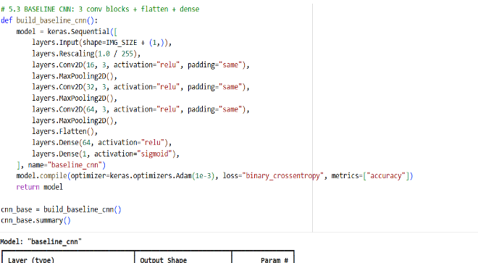
MLP CNN

5. Industrial Implications
The two error types carry onsequences first is false negative ships a defective unit and risking warranty claims and also safety incidents recalls and reputational damage the Random Forest let 130 of 545 defective units (24%) through false positive sends a good unit to waste and requires rework or manual inspection wasting material and labour but rarely any problem to customers here 33 of 103 good units (32%) were known as ok which is normal precision of 0.350 matters equally a “pass” prediction was correct only about a third of the time, so the model cannot certify a unit as good. Because real costs are unknown the threshold should follow a cost-based rule, since the cost-minimisig threshold falls as false negatives become more expensive relative to false positivs (Elkan, 2001). The default of 0.5 reflects no such judgemen the 84.1% defect prevalence is also unusua where defects are rare, the same false-positive rate would sharply reduce precision (Saito and Rehmsmeier, 2015).
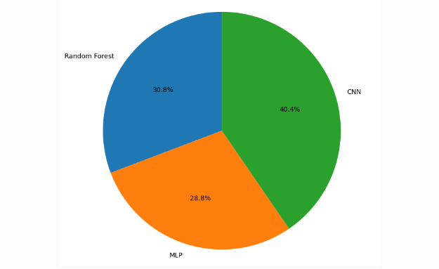
Shared of combine test recall scores

7. Limitations and recommendations
The tabular data is synthetic so that the ROC-AUC near 0.75 may reflect how the data was generated rather than the real process behavior. Real sensor data often shows temporal dependence and drift. The image data is one type of casting with fixed camera and lighting and downsampling to 128×128 may hide fine defects. The datasets also cover different products, so the models were never evaluated as a combined system results is single splits and seeds, no confidence intervals High test performance is no guaranty of reliability in the real world, because production conditions change through tool wear lighting, new suppliers or sensor comparing
producing data drift (Gama et al., 2014). Missed defects carry the greatest cost a 24% miss rate at 0.5 is unacceptable for a sole gate and the notebook found that maximising F1 alone predicted every unit as defective a consequence of the dominant defective class. The CNN also requires GPU or edge hardware and camera which can go high in buget
the proposed deployment a random Forest for process monitoring and a CNN for visual inspection is a better approach random forest is cheap and understabale and the CNN is perfect for visible defects that process data cannot Both remain unvaidated for production.
8. Conclusion
The Random Forest slightly outperformed the MLP and was better than MLP in factors of recall and F1 at the default threshold with equivalent ranking quality and ranked equally while the CNN classified all 715 casting images correctly with no problem including after duplicate removal neither approach is better it is suitability depends on the data and the price of missed defects and the need for explanation that why it happened the most defensible recommendation is a two-stage system with random forest used to detect any early warning monitor and a CNN as an end-of-line inspection gate because it can really help visually each deployed only after real-world problem and can help fix it threshold tuning and drift monitoring the results are promising but limited by synthetic tabular data and narrow imaging conditions it can get better if performed on real data

Reference List
Barz, B. and Denzler, J. (2020) ‘Do we train on test data? Purging CIFAR of near-duplicates’, Journal of Imaging, 6(6), article 41. doi:10.3390/jimaging6060041.
Breiman, L. (2001) ‘Random forests’, Machine Learning, 45(1), pp. 5–32. doi:10.1023/A:1010933404324.
Czimmermann, T., Ciuti, G., Milazzo, M., Chiurazzi, M., Roccella, S., Oddo, C.M. and Dario, P. (2020) ‘Visual-based defect detection and classification approaches for industrial applications: a survey’, Sensors, 20(5), article 1459. doi:10.3390/s20051459.
Dabhi, R. (2020) Casting product image data for quality inspection [Dataset]. Kaggle. Available at: https://www.kaggle.com/datasets/ravirajsinh45/real-life-industrial-dataset-of-casting-product (Accessed: 21 October 2026).
El Kharoua, R. (2024) Predicting manufacturing defects dataset [Dataset]. Kaggle. Available at: https://www.kaggle.com/datasets/rabieelkharoua/predicting-manufacturing-defects-dataset (Accessed: 21 October 2026).
Elkan, C. (2001) ‘The foundations of cost-sensitive learning’, in Proceedings of the 17th International Joint Conference on Artificial Intelligence. San Francisco, CA: Morgan Kaufmann, pp. 973–978.
Fawcett, T. (2006) ‘An introduction to ROC analysis’, Pattern Recognition Letters, 27(8), pp. 861–874. doi:10.1016/j.patrec.2005.10.010.
Gama, J., Žliobaitė, I., Bifet, A., Pechenizkiy, M. and Bouchachia, A. (2014) ‘A survey on concept drift adaptation’, ACM Computing Surveys, 46(4), article 44. doi:10.1145/2523813.
Goodfellow, I., Bengio, Y. and Courville, A. (2016) Deep learning. Cambridge, MA: MIT Press. Available at: https://www.deeplearningbook.org.
Grinsztajn, L., Oyallon, E. and Varoquaux, G. (2022) ‘Why do tree-based models still outperform deep learning on typical tabular data?’, in Advances in Neural Information Processing Systems 35 (NeurIPS 2022), Datasets and Benchmarks Track.

